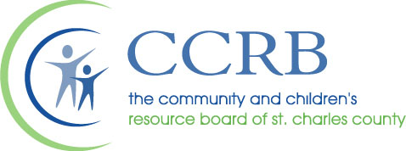

Board of Directors Meeting
July 24, 2023

AGENDA
The Community & Children’s Resource Board of St. Charles County will hold their monthly Board meeting at 8:00 a.m on Monday, August 28, 2023 at TREE House of Greater St. Louis 332 Stable Lane, Wentzville, MO 63385. Public Comment must be emailed to info@scckids.org or given to the CCRB staff by the start of the meeting.

- Meeting Call to Order

- Roll Call

- Approval of the July 24, 2023 Board Minutes

- Audit Report - Sikich

- Partner Presentation – FamilyForward
Megan Meier Foundation

- Public Comment

- Report of the Chair

- Report of the Treasurer

- Report of the Standing Committees
  - Finance
  - Personnel
  - Executive: Policies and Procedures

- Report of the Executive Director
  - MINDREACH update – Anna Muhm
  - Spring Site Audit Report – Michelle McElfresh

- Old Business

- New Business
  - Supplemental Funding
    - The Child Advocacy Center Of Northeast Missouri (three programs)
    - Gateway Alliance Against Human Trafficking
  - Line-Item Transfer – LINC St. Charles County
  - Missouri Ethics Commission Re-approved

- Announcements

- Adjournment

The next Board Meeting will be held at a different time, 8:30 a.m. on Monday, September 25, 2023 at Eleventh Judicial Circuit Court, 300 North Second Street, St. Charles MO, 63301.

